Why Construction Submittals And RFIs Need To Live Closer To Project Financials
Meta: Submittals and RFIs affect cost, procurement, schedules, and billing. See why contractors need project documents closer to financial control.
Keywords: NetSuite construction project management, construction submittal software, construction RFI software, submittal tracking software, RFI tracking software, construction document management in NetSuite, job costing and submittals, construction financial visibility, submittal approval workflow, RFI management for contractors, daily reports in NetSuite
URL Slug: /construction-submittals-rfis-financial-visibility/

Project documents have a strange way of looking harmless until they start affecting money. A submittal waits on approval, a vendor replies in a separate email thread, an RFI sits open while field teams need direction, and a daily report captures job-site issues that finance may not see until much later. None of that feels like a major accounting problem at first. Then procurement slows down, a change order gets harder to explain, or someone has to reconstruct a decision trail during billing review.
That is the gap many contractors deal with every day. Project teams move fast, but financial systems often find out after the work has already shifted. The people managing submittals, RFIs, daily reports, purchase documentation, and field communication are not always working from the same context as the teams handling cost, billing, WIP, revenue recognition, and reporting.
That separation creates friction. It also creates risk. Submittals and RFIs are not just operational paperwork. They influence schedule confidence, procurement timing, cost exposure, vendor accountability, change-order support, and project margin. If contractors want better financial control, project documentation has to move closer to the systems that make financial decisions.

Construction Documents Are Not Just Documents
A submittal is not only a file waiting for approval. It is proof that a material, product, drawing, specification, fixture, piece of equipment, or other project detail has been reviewed before purchase or installation. If that approval is delayed or unclear, the impact can ripple across purchasing, delivery timing, field coordination, and project cost.
RFIs carry similar weight. A Request for Information establishes a formal process for clarifying drawings, specifications, conflicts, missing details, or field conditions. A fast, clean answer can keep work moving. A buried or delayed answer can create confusion, rework, schedule pressure, or disputes over who knew what and when.
Daily reports add another layer. They capture job-site activity, labor, conditions, delays, notes, progress, and issues. They are often treated as field records, but they can become important context for schedule claims, internal reviews, cost conversations, and project performance analysis.
These workflows shape the project story. They help explain what was approved, what changed, who responded, what was delayed, and which details affected cost or schedule. When that story lives in disconnected systems, contractors lose the ability to connect project activity with financial truth.

The Usual Workflow Is Too Fragmented
Many construction companies are not struggling because they lack tools. They are struggling because they have too many disconnected ones. A contractor may use Procore for field or project activity, Smartsheet for trackers, Excel for quick lists, email for vendor responses, shared folders for files, and NetSuite for finance. Each tool may serve a purpose, but the full picture gets harder to control.
The problem is not only inconvenience. It is the loss of context between project work and accounting. Documents live in one place. Costs live somewhere else. Vendor communication gets buried in inboxes. Purchase orders may be created without an easy trail back to the submittal, package, RFI, or field issue that started the conversation.
That creates familiar headaches:
- Project managers lose time chasing the current status of submittals and RFIs.
- Finance teams see costs without always seeing the project-side reason behind them.
- Vendors and subcontractors respond through scattered email threads.
- Revisions become hard to trace when files move through too many informal paths.
- Change orders and billing support may require manual digging after the fact.
- Executives get delayed visibility into open items that could affect project performance.
This is where document management alone starts to fall short. Contractors need more than just a place to store files. They need a better way to connect documentation, ownership, status, cost detail, and financial context.
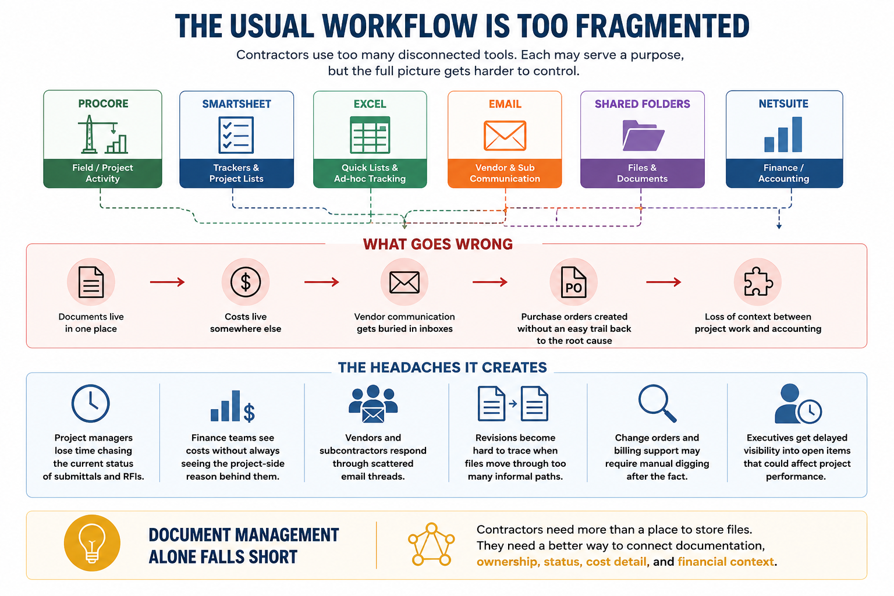

Why Submittals Need Financial Context
Traditional submittal tracking often focuses on whether an item is open, closed, submitted, approved, revised, or overdue. Those details matter, too, but they do not tell the whole story. A submittal can represent materials, quantities, unit costs, delivery timing, manufacturers, models, approval chains, and procurement decisions.
That means the financial side of the business needs more than a status update. It needs to understand what is being approved, what it may cost, what purchasing activity it could trigger, and how it connects to the project record.
Line-item visibility changes the value of a submittal workflow. If teams can track item descriptions, quantities, unit costs, delivery status, receipt dates, manufacturers, models, and approvers, the submittal becomes more than a document. It becomes part of the project’s financial and operational context.
For contractors, this is important because the financial impact of a project decision often begins before an invoice is issued. It may begin with a product selection, a submitted material, a revised approval, a delayed response, or a detail that changes the way the job is bought out. The earlier that context is visible, the easier it is to manage the project with confidence.

RFIs Can Create Cost And Schedule Risk
RFIs are often treated as tools for clarification, and that is accurate. Yet the clarification itself can carry real business weight. An RFI might confirm that a detail is missing, a drawing conflicts with field conditions, a scope assumption needs review, or a design decision requires a change.
If the RFI process is informal, the risk grows. Someone may answer in an email thread that not everyone sees. A response may arrive late. A file may be attached in one system while the cost impact gets discussed in another. A project manager may know the background, while accounting only sees the financial result later.
A strong RFI workflow helps contractors protect the decision trail. It should show who asked the question, who owns the answer, when it is due, which files are attached, the status, and how the response fits into the official project record.
That kind of visibility helps project teams move faster and helps finance and leadership understand project risk earlier. If RFIs are piling up, aging, or connected to cost-sensitive decisions, the business should not have to wait for a month-end surprise to see the problem.

Email Is Useful, But It Should Not Own The Record
Email is not going away in construction. Vendors, subcontractors, suppliers, architects, engineers, and other outside parties still rely on it because it is familiar and easy. The issue is not that email exists. The issue is what happens when email becomes the official system of record.
Important project decisions should not live only in someone’s inbox. A vendor response, submittal comment, RFI clarification, or approval note needs to be attached to the project record where the right team can find it later. Otherwise, every review turns into a search party.
A better workflow keeps email convenient for outside parties while pulling the response back into the system contractors trust. That reduces friction for vendors and subcontractors, while giving internal teams a cleaner record.
This is especially important for external collaboration. Contractors should not have to force every external contact into an expensive or annoying login workflow just to respond to a single submittal or clarification request. The easier the response process is, the more likely the project record stays complete.

Revision History Protects The Project Trail
Construction teams know the pain of version confusion. A file gets updated, a new revision goes out, an old attachment keeps floating around, and someone eventually asks which version is current. That confusion can slow approvals, lead to field errors, and make later review more difficult.
Revision history is not just administrative cleanup. It protects the integrity of project decisions. A clean version chain shows how a document changed, which revision replaced the prior one, and what information should be used moving forward.
For submittals, this is especially important. Rev 0, Rev 1, Rev 2, and later versions need to be easy to identify. Older revisions should remain available for the record, but they should not compete with the current version. If older revisions are read-only, teams can preserve history without creating confusion.
That gives project teams a clearer workflow and gives managers a stronger audit trail. If questions come up later, the record can show how the document moved through review instead of relying on memory or inbox archaeology.

Daily Reports Add Field Reality To The Financial Picture
Daily reports may not always feel connected to finance, but they often explain the conditions behind financial outcomes. A delay, site issue, staffing problem, delivery conflict, weather event, or field note can become important contexts for project performance.
If daily reports are isolated from the broader project environment, that context becomes harder to use. Project managers may know what happened. Field teams may have captured it. Operations may have discussed it. Finance may still lack a clear connection between field activity and the numbers that show up later.
Bringing daily reports closer to the project and ERP environment gives contractors a better operating record. It helps connect job-site activity to project oversight, management review, and financial visibility.
This is very important because construction does not happen in spreadsheets alone. The numbers are shaped by field conditions, project decisions, document approvals, delays, labor movement, and communication. A strong project system with streamlined workflows should make that connection easier to see.

BlueCollar PM Features Bring Project Workflows Into NetSuite
BlueCollar PM Features are designed to bring construction project management and document management workflows into BlueCollar Projects inside NetSuite. The module focuses on the workflows contractors already rely on, including submittals, submittal packages, RFIs, analytics, and potentially daily reports depending on final launch readiness.
The larger value is not only that BlueCollar adds more tools. The stronger story is that BlueCollar helps close the gap between project documentation and financial control. NetSuite remains the ERP foundation for accounting, reporting, procurement, billing, dashboards, audit trail, consolidation, and financial management. BlueCollar adds the construction-layer capabilities contractors need for job costing, billing workflows, cost codes, WIP, change orders, retainage, and project-level visibility.
That provides a more practical solution for construction companies that want ERP discipline without sacrificing contractor-specific workflow depth. For years, the idea that NetSuite was not built for construction was a fair objection. With BlueCollar on top of it, that objection becomes easier to answer.
For teams evaluating NetSuite construction project management, the real question is not whether generic ERP can magically behave like a contractor system on its own. The better question is whether the right construction layer can bring field, project, and finance workflows into a more connected environment.

What BlueCollar Adds To Submittal Management
BlueCollar provides project teams with a structured way to manage submittals within the BlueCollar and NetSuite environments. Instead of relying on loose spreadsheets or scattered trackers, teams can work from a submittal list view that includes the details needed to understand workflow health.
A strong submittal record can include the submittal number, CSI spec section, title, type, revision, status, ball-in-court, assignee, manager, due date, and days open or closed. Those details help project managers quickly see what is moving, what is stuck, and who owns the next step.
BlueCollar also supports submittal packages, which help group related submittals under a common deliverable, scope area, trade, project phase, or approval path. That matters on larger jobs where reviewing one item in isolation does not give teams the full picture.
The submittal line-item detail is where the workflow becomes more cost-aware. BlueCollar can track item description, manufacturer, model, quantity, unit cost, delivery status, submitted status, receipt date, and approver. That gives teams a clearer link between document tracking and project financial visibility.
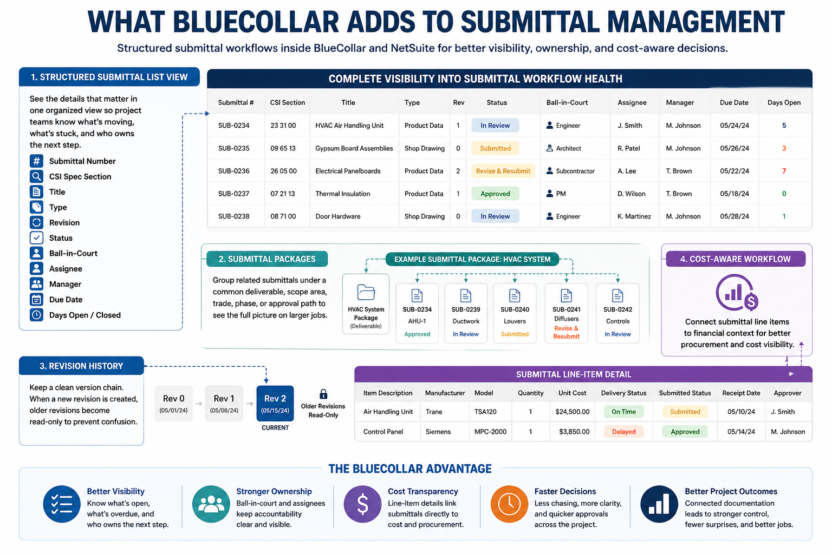

What BlueCollar Adds To RFI Management
BlueCollar’s RFI workflow provides contractors with a more structured approach to managing project questions and clarifications. Instead of letting important issues get buried in email, project teams can track RFIs by status, assignee, manager, due date, files, and project record.
That gives teams a cleaner answer to basic but important questions. What is open? Who owns it? When is it due? What files are attached? Has the response been captured? Is this issue connected to a larger project or cost concern?
For field teams and project managers, this reduces the need to manually chase down answers. For finance and operations, it creates a more reliable record of the decisions and clarifications that may later affect cost, schedule, change orders, or billing.
A cleaner RFI trail does not eliminate construction complexity. It gives teams a better way to manage it before confusion becomes expensive.
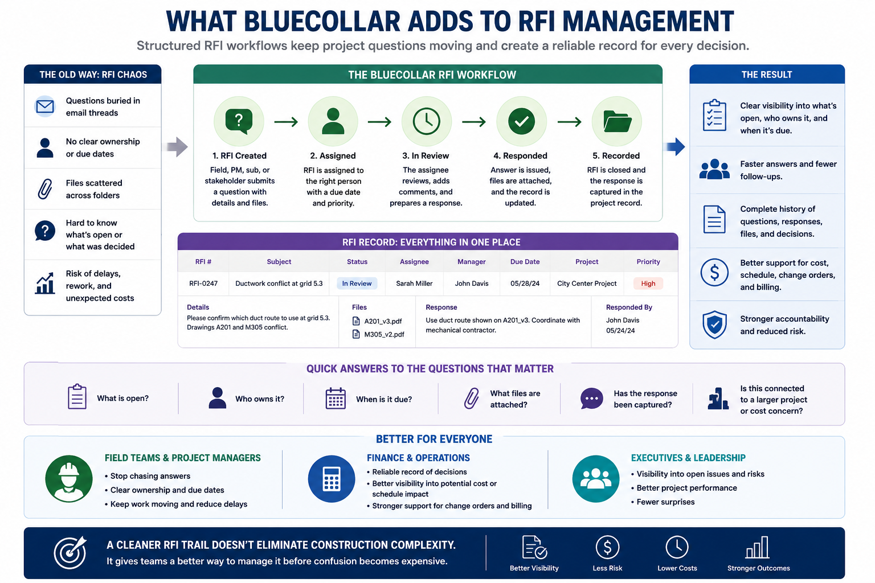

Analytics Help Teams See Workflow Health Sooner
A project leader should not have to dig through every submittal and RFI record to understand whether documentation is under control. BlueCollar’s analytics view gives teams a dashboard-style snapshot of open and closed items for submittals and RFIs.
That kind of visibility sounds simple, but it can be powerful. Open counts can show where work is building up. Closed counts can show progress. Aging items can raise questions before they create broader friction in the project.
For managers, analytics can support better follow-up. For executives, it provides a clearer picture of the health of project documents. For finance, it can offer early signals that project activity may need attention before it affects month-end review, billing, or cost control.
Project documentation should not be invisible until something goes wrong. Analytics help bring that work into view.
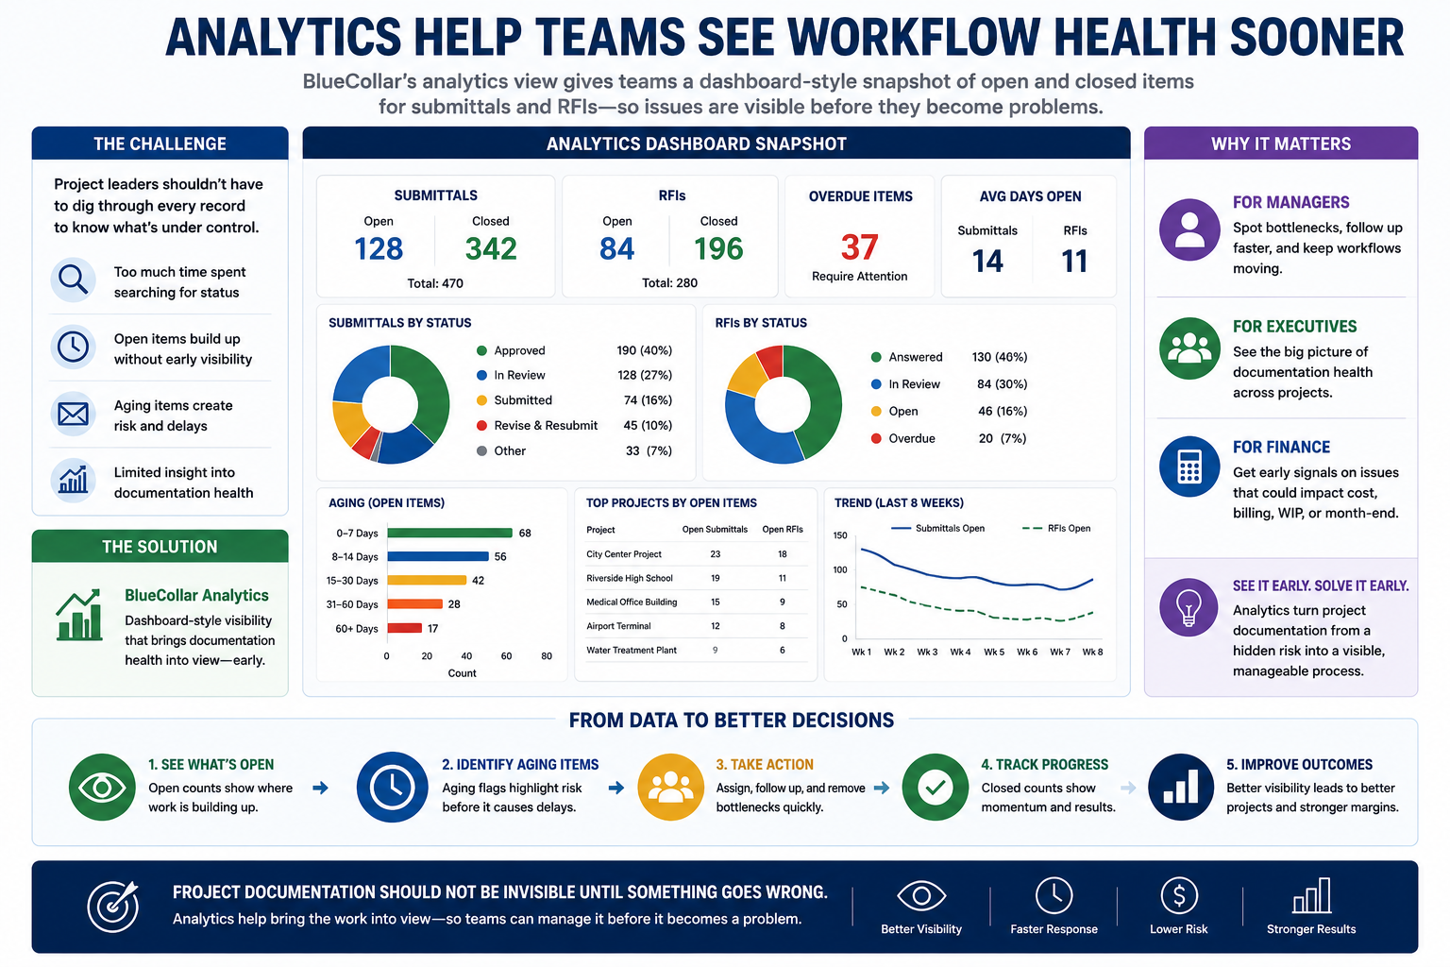

BlueCollar Versus Spreadsheets, Email, And Standalone PM Tools
Spreadsheets and email are easy to start with because everyone knows how to use them. The problem is that they do not hold up well at scale. Status, ownership, revisions, files, due dates, and approvals become harder to trust as the project grows.
Standalone construction PM platforms can be strong for submittals, RFIs, and field workflows. For many contractors, those tools still have a place. The issue is that they can sit too far away from NetSuite financial workflows, which means finance and project teams may still operate from different versions of the same job.
NetSuite alone provides contractors with a strong ERP foundation, but it was not designed as a complete construction document management system. That is where BlueCollar fits. It adds the contractor-specific workflows that help make NetSuite more credible for construction companies.
Legacy construction ERP systems may offer depth, but many contractors find them rigid, dated, or harder to extend. BlueCollar and NetSuite create a different model: modern ERP scale with construction-specific workflow depth layered where contractors need it.
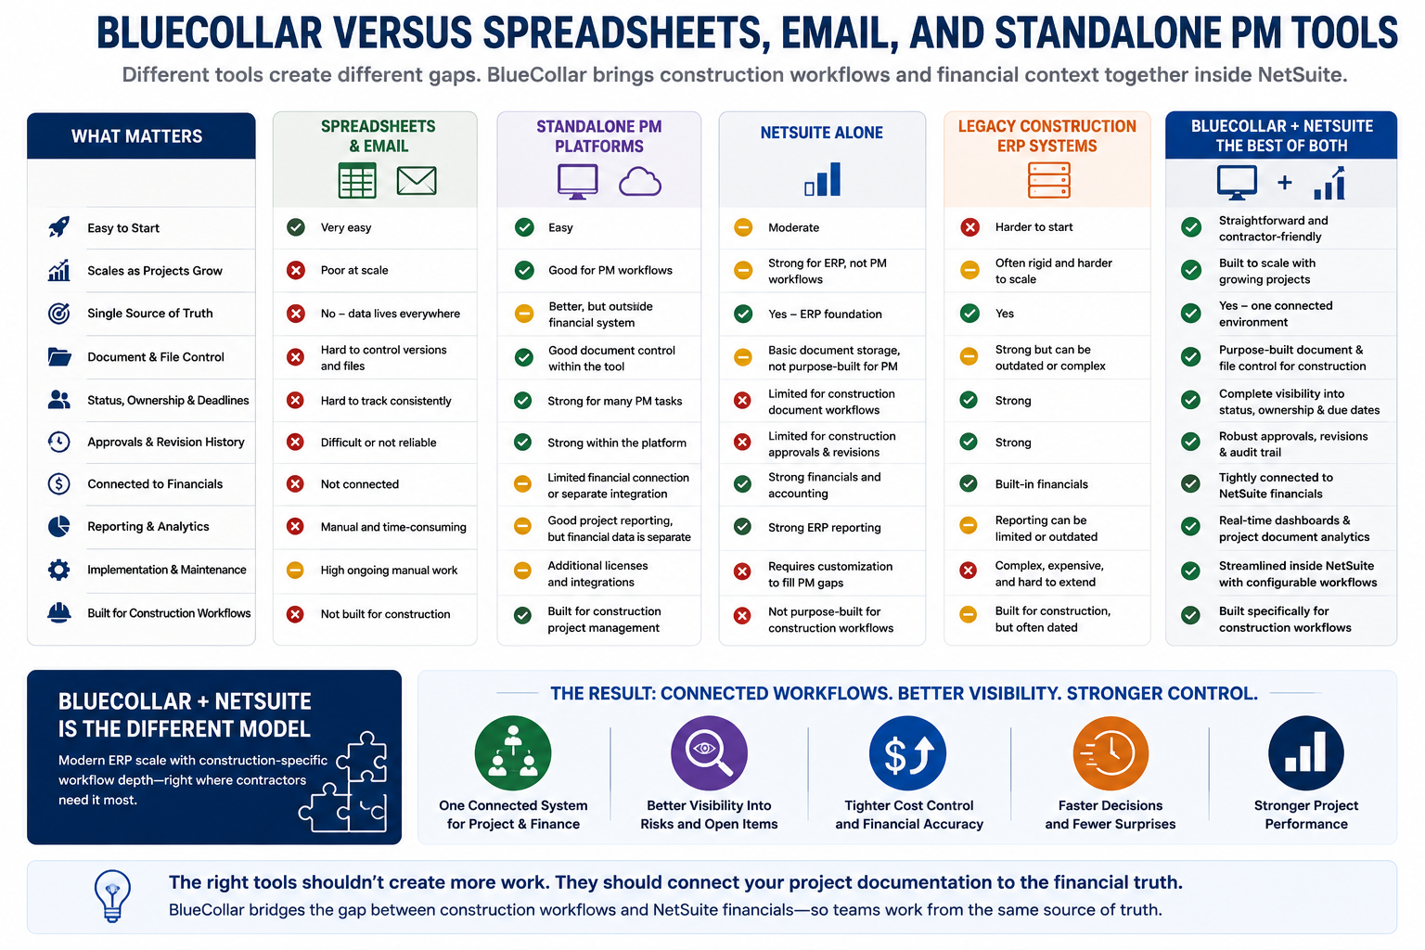

The Buyer Benefits Are Different Across The Company
One reason this kind of workflow matters is that different teams feel the pain in different ways.
For CFOs, controllers, and finance leaders, disconnected documentation makes it harder to trust project context. They care about billing accuracy, WIP, revenue recognition, retainage, cost visibility, auditability, and month-end speed. When project documents sit closer to financial workflows, the numbers become easier to explain and defend.
For project managers and project controls teams, the benefit is daily clarity. They need to know which submittals are open, which RFIs need answers, which revisions are current, and which vendors or internal stakeholders own the next step. They do not need another clunky system that slows them down.
For IT leaders and NetSuite admins, the value is governance. Configurable workflows, permissions, notification triggers, status rules, and project record traceability help reduce tool sprawl while keeping data more controlled.
For executives, the benefit is visibility. Better project documentation does not only help the people in the weeds. It gives leadership a clearer view of risk, progress, bottlenecks, and project health.

A Better Way To Talk About NetSuite For Construction
Contractors are right to be skeptical of vague ERP promises. NetSuite alone does not automatically do everything a construction ERP should do. That is not the message BlueCollar should lead with, because it creates a credibility problem.
The better message is more honest and more useful. NetSuite is a powerful ERP foundation. BlueCollar adds the construction-specific layer that contractors need to make it work for their world.
That construction layer includes the workflows contractors expect, such as AIA billing, retainage, WIP, percent-complete revenue recognition, job costing, cost codes, change orders, subcontract management, field data capture, and project-level financial visibility. PM Features extend that story into project documentation, submittals, RFIs, analytics, and daily reporting.
For NetSuite partners and consultants, that positioning matters. It gives them a stronger way to answer construction objections without pretending NetSuite was built for every contractor workflow out of the box.

Project Documentation Should Support Financial Control
Submittals, RFIs, daily reports, and project documents do not live in a vacuum. They influence real business outcomes. A delayed approval can affect procurement. A missed revision can create field confusion. An RFI response can lead to a change order. A daily report can explain conditions that later affect cost, schedule, or claims.
That is why contractors need project documentation closer to financial control. Not because every PM needs to think like an accountant. Not because every field workflow should become slow or overly formal. Contractors need it because the project and the financial story are already connected, even when the systems are not.
BlueCollar PM Features help contractors bring that connection into the NetSuite environment. Project teams gain cleaner workflows for submittals, RFIs, analytics, and daily reports. Finance teams gain better context. Executives gain stronger visibility. NetSuite becomes a more credible ERP foundation for construction because BlueCollar adds the contractor-specific layer around it.

Bring Project Workflows Closer To The Financial Backbone
Project documentation should not be financially blind. Submittals, RFIs, daily reports, and approval records carry too much influence over cost, procurement, schedule, and billing to sit in disconnected tools with limited financial context.
BlueCollar’s PM Features bring construction project management workflows into BlueCollar Projects inside NetSuite, helping contractors connect documentation, ownership, revisions, email communication, analytics, and cost visibility in a more controlled environment.
See how BlueCollar Projects brings submittals, RFIs, analytics, and project document workflows closer to NetSuite financial control. Book a demo to see PM Features in action.

Frequently Asked Questions About Construction Submittals And RFIs
What Are Construction Submittals?
Construction submittals are formal documents that demonstrate that proposed materials, products, drawings, equipment, or specifications meet the requirements of a project. They usually need to be reviewed and approved before the related work, purchase, or installation moves forward. Submittals help protect quality, reduce confusion, and create a record of what was accepted for the job. They can also affect cost, procurement, delivery timing, and project coordination.
What Is An RFI In Construction?
An RFI, or Request for Information, is a formal question used to clarify drawings, specs, field conditions, missing information, conflicts, or other project details. RFIs help teams avoid guessing when the next step is unclear. A strong RFI process creates a record of the question, the response, the responsible parties, the files, the due dates, and the status. That record can become important if the clarification affects cost, schedule, scope, or billing.
Why Should Submittals And RFIs Be Connected To Financials?
Submittals and RFIs often influence cost, procurement, change orders, schedule risk, and billing confidence. If those workflows are far from the financial system, accounting teams may see the dollar impact without the project context behind it. Connecting project documentation more closely to financial workflows gives contractors a clearer trail from decision to cost. It also helps teams reduce manual research during project review, billing, and closeout.
Can NetSuite Handle Construction Project Management?
NetSuite is a strong ERP foundation, but it was not designed to handle every contractor-specific project management workflow. BlueCollar adds construction-focused workflows on top of NetSuite, including tools for job costing, billing, WIP, cost codes, change orders, and project documentation. That makes the NetSuite environment more practical for contractors that need both financial control and construction workflow depth. The key is positioning NetSuite as the ERP foundation and BlueCollar as the construction layer.
What Are Submittal Packages?
Submittal packages group related submittals under a common scope, trade, phase, CSI section, deliverable, or approval path. This helps project teams manage related documentation together rather than tracking each submittal as a standalone item. Packages can give PMs and managers a clearer view of whether a larger scope is progressing or being delayed. They are especially useful on larger jobs with many materials, vendors, trades, and approval steps.
Why Do Submittal Line Items Matter?
Submittal line items matter because they add detail beyond basic document status. A line item can include information such as description, manufacturer, model, quantity, unit cost, delivery status, receipt date, and approver. That helps connect the submittal to procurement, cost visibility, and project control. Contractors gain a better understanding of what is being reviewed, what it may cost, and how it fits into the project record.
Does BlueCollar Replace Procore?
BlueCollar does not have to replace Procore in every environment. Some contractors may keep Procore where it works well for field and project teams while using BlueCollar and NetSuite as the financial, accounting, billing, WIP, and reporting backbone. For PM Features, the focus is bringing construction document workflows into the BlueCollar Projects environment inside NetSuite. The right setup depends on how the contractor wants to manage field workflows, project documentation, and financial control.
What Are Daily Reports In Construction?
Daily reports capture what happened on the job site during a specific day. They can include labor, weather, progress, delays, notes, issues, visitors, equipment, and other operating details. These reports help preserve field context that may become important later during project review, schedule analysis, billing discussions, or dispute support. When daily reports sit closer to the project and ERP environment, contractors can use that field information more effectively.
How Do Analytics Help With Project Documentation?
Analytics give teams a quick view of the health of the project document workflow. Instead of manually checking every submittal or RFI, managers can see open and closed counts and identify areas that may need follow-up. This helps project leaders spot bottlenecks earlier and gives executives better visibility into documentation activity. Better visibility can support stronger project control before open items become cost or schedule problems.

